# Register a Domain Name-Route 53

**Pre-requesties:**

1. Register a Domain Name with Amazon Route 53

You will then connect that domain name through the Domain Name System (DNS) to a currently [running EC2 instance](https://aws.amazon.com/getting-started/tutorials/launch-a-virtual-machine/) .

1. Launch an instance (amazon linux,ubuntu,windows machine)

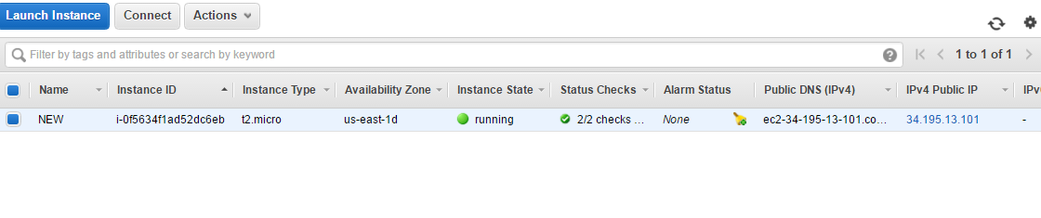

1. Obtain static url -Associate with the elastic ip address to get a static ip address or associate new address(In open network)

**Register Domain Name**

1. Now that you have an IP address associated with your instance, we will need to configure the Domain Name System (DNS) to point to this address so that people can find your website.
2. You can register new domain names with Route 53 as well as manage DNS records for your domain.
3. Select Get Started Now under Domain Registration.

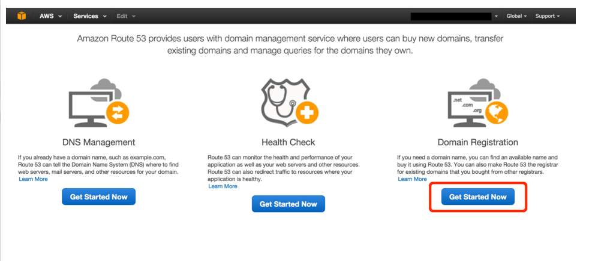

1. Click the Register Domain button. On the next screen, enter the domain you want in theChoose a Domain box (cloudexamples is shown in the image, then select a Top Level Domain(TLD) (e.g. .com, .org, .co.uk, etc.) And click the Check button to see if the domain is available. If the domain is available, click the Add to cart button and scroll to the bottom of the page to clickContinue.

Note: Domains are not part of the free tier so you will be charged for any domain you register.

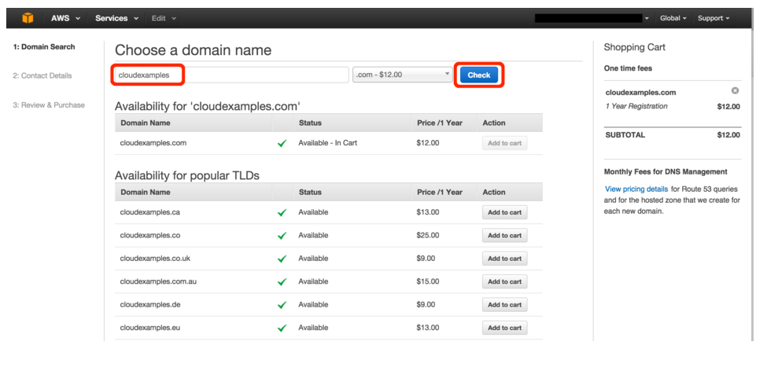

1. Enter your Contact Details. These are the details that will be associated with your domain name. When you are done, click Continue at the bottom of the page.

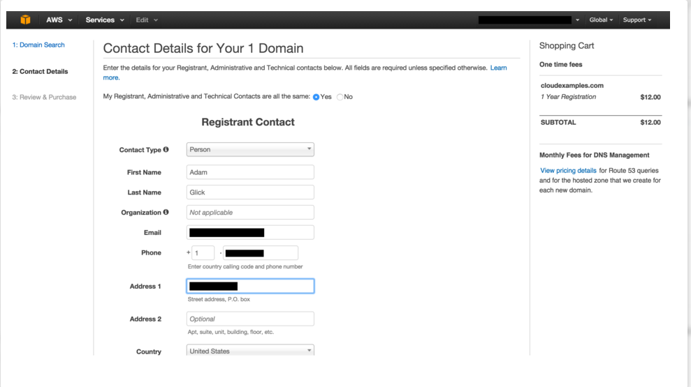

1. Review the details as they are listed and, if they are correct, check the box titled I have read and agree to the AWS Domain Name Registration Agreement. Then click the Complete Purchasebutton.

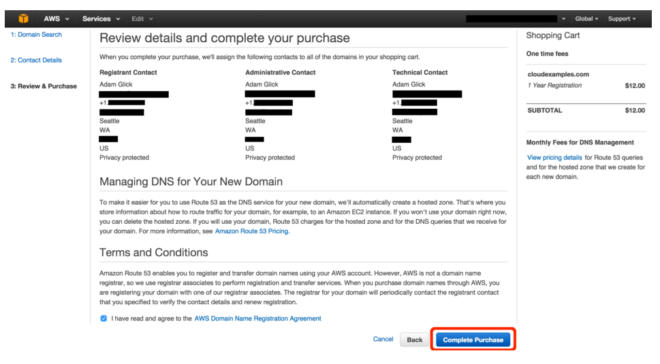

1. If you registered a domain that has a [generic top-level domain](http://docs.aws.amazon.com/Route53/latest/DeveloperGuide/registrar-tld-list.html#registrar-tld-list-generic) (such as .com), you'll receive an email that asks you to confirm your email address. You must follow the link in this email to confirm your email address, or the domain won't be registered.
2. For all domains, you'll receive an email when your domain registration has been approved.

Note: it can take a few minutes for the system to confirm the registration of your new domain.

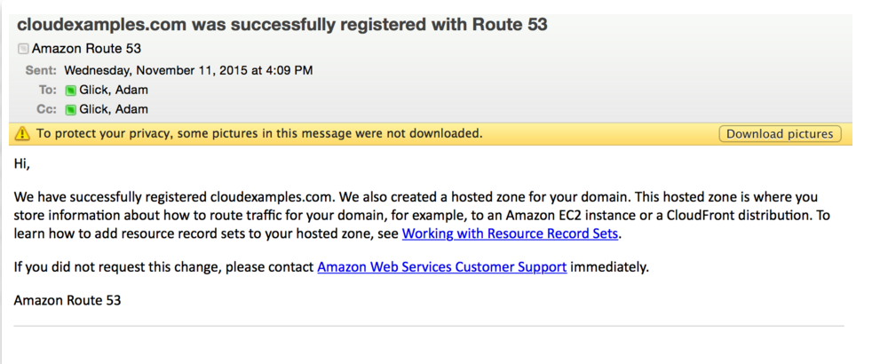

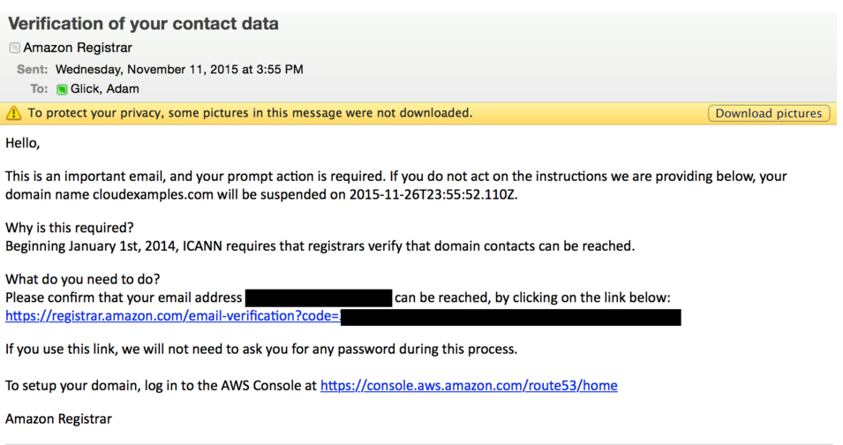

**Configure DNS**

To configure the DNS so that the new domain we created in step 2 can point to the address we have for our server.  This can be the static IP address (from step 1) or a fully qualified domain name (FQDN) that is automatically created if you are using Amazon Elastic Beanstalk.

1. Open the Hosted Zones part of the Route 53 console , click on the domain name you created in step 2 (in this example we are using cloudexamples.com but your domain will be different).

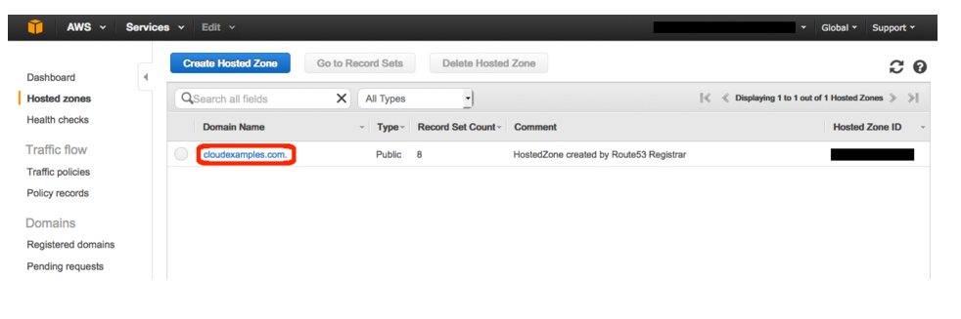

1. If you have a static IP address for your website, virtual server, or service; select Static IP Address below.

If you have a Fully Qualified Domain Name (FQDN) for your resourse (this is common for applications launced by Elastic Beanstalk, Lambda functions, S3 static sites and more advanced deployments using Elastic Load Balancing) please select Fully Qualified Domain Name (FQDN) below.

* + 1. **Static IP Address**

Click the Create Record Set button. On the right side of the window, enter www in the Nametext box. Enter the Elastic IP address you created in step 1 in the Value box and then clickCreate.

* + 1. **Fully Qualified Domain Name**

Click the Create Record Set button. On the right side of the window, enter www in the Nametext box. Enter the Elastic IP address you created in step 1 in the Value box and then clickCreate.

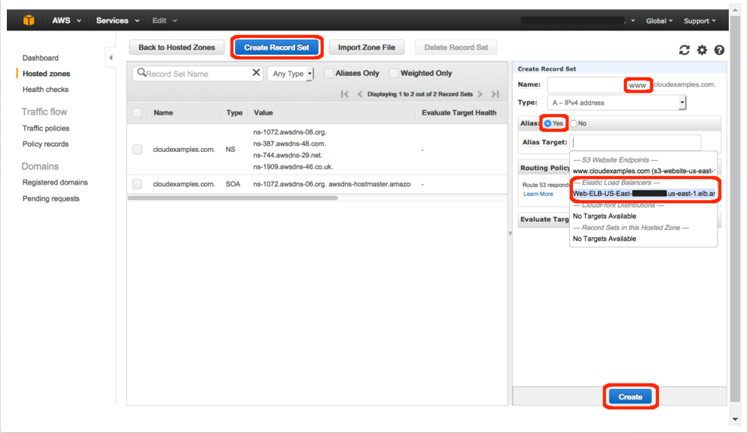

1. Verify that you have a new entry in the main table with the value you entered.

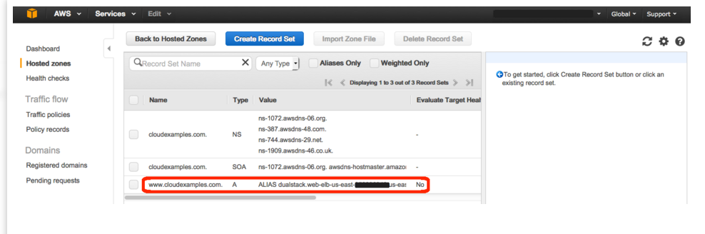

1. Verify that you website is now available at your new domain by typing your new website address into your web browser

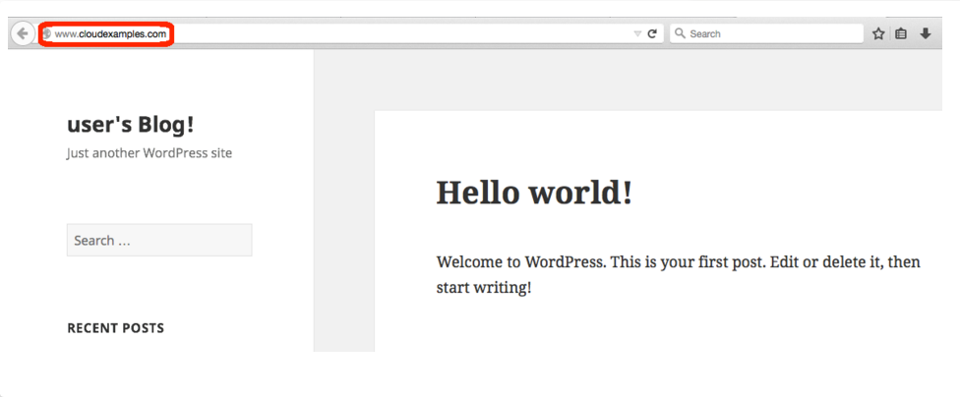

Now we have successfully registered the domain !!!